A000-Afr-Egy-Horus-alabaster

Case no. 2

Collection of the Late Michael Verney-Elliott

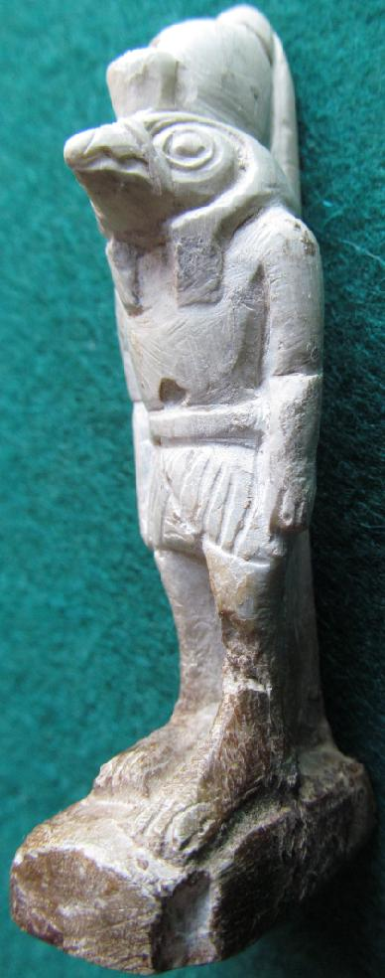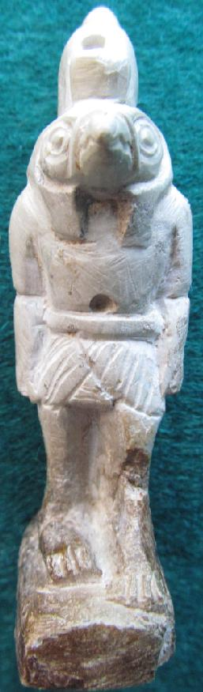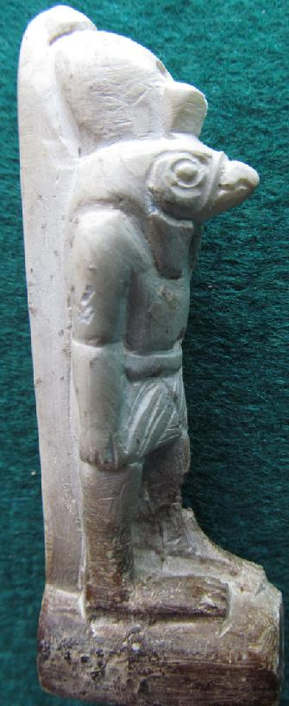

|  |
| --- |
| Shipping details |
| **Ralph J Coffman Jr**  149 Atlantic Ave  Swampscott MA 01907-2427  United States |

## Order details

|  |  |  |  |
| --- | --- | --- | --- |
| **Item title** | **Available actions** | **Shipping & handling (estimated delivery*)** | **Price** |

[Printer version](http://payments.ebay.com/ws/eBayISAPI.dll?ViewPaymentStatus&transid=0&userloginid=802-867&printerversion=true&itemid=390515814566)

|  |  |  |
| --- | --- | --- |
| Seller: | [**Member id** russelliott](http://myworld.ebay.com/russelliott) ( [**Feedback Score Of** 4536](http://feedback.ebay.com/ws/eBayISAPI.dll?ViewFeedback&userid=russelliott)) | [Contact seller](http://contact.ebay.com/ws/eBayISAPI.dll?ShowCoreAskSellerQuestion&frm=3998&iid=390515814566&redirect=0&requested=russelliott) |

|  |  |  |  |  |
| --- | --- | --- | --- | --- |
| Paid on Dec-23-12 via PayPal | | | | |
|  |  |  |  |  |

|  |  |  |  |  |  |  |  |  |
| --- | --- | --- | --- | --- | --- | --- | --- | --- |
|  | [**Item Title:**Authentic Ancient Egyptian Baby Horus & Shabti Figurines**- opens in a new window or tab**](http://cgi.ebay.com/ws/eBayISAPI.dll?ViewItem&item=390515814566)  **Item Id:**390515814566 - Price: GBP 207.55  Quantity:1  **eBay note:** Payment was recorded and this unpaid item case has been closed. | |  | | --- | |  | | |  |  | | --- | --- | | [Leave feedback](http://feedback.ebay.com/ws/eBayISAPI.dll?LeaveFeedbackShow&useridfrom=802-867&useridto=russelliott&item=390515814566&transactid=0) |  | | | Standard Int'l Postage : **GBP 9.99**  Estimated delivery: Varies* You can [contact the seller](http://contact.ebay.com/ws/eBayISAPI.dll?ShowCoreAskSellerQuestion&frm=3998&iid=390515814566&SSpagename=PageAskSellerQuestion_VI&redirect=0&requested=russelliott) for more information. | GBP 207.55 |



|  |  |  |  |  |
| --- | --- | --- | --- | --- |
|  | |  | | |
|  | |  | | --- | |  | | [Ad Feedback](javascript:void(0);)|[AdChoice **- opens in a new window or tab**](javascript:void(0);) | | | |  |  |  |  |  |  |  |  |  |  |  |  |  |  |  |  |  |  | | --- | --- | --- | --- | --- | --- | --- | --- | --- | --- | --- | --- | --- | --- | --- | --- | --- | --- | | |  | | --- | | |  |  |  |  |  |  |  |  |  |  |  |  |  |  |  | | --- | --- | --- | --- | --- | --- | --- | --- | --- | --- | --- | --- | --- | --- | --- | | |  |  | | --- | --- | | Subtotal: | GBP 207.55 | |  | | | Shipping & handling: | GBP 9.99 | |  | | |  | | |  | | | Total: | GBP 217.54 | | | | |  |